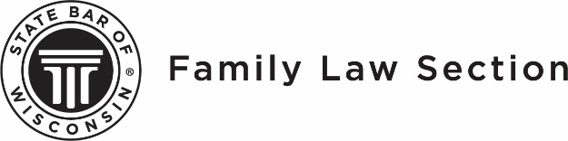

40TH ANNUAL FAMILY LAW WORKSHOP | AUGUST 5-6, 2021

Name: _________________________________________ State Bar Number______________
Firm/Organization:_____________________________________________________________
Address:_____________________________________________________________________
City:_______________________ State:_______________ Zip Code:_____________________
Email:_______________________________________________________________________
PROGRAM REGISTRATION:
Please check if you will be attending Day 1, Day 2 or both days
Tuition Price categories | Day 1 | Day 2 | Both Days
Family Law Section Member - $100 single day/$175 both days
Family Law Section Member - First Workshop - $80 single day/$150 both days
Non-Section Member- $125 single day/$225 both days
Law Student or Paralegal - $60 single day/$$100 both days
Tuition cost

Join Family Law Section for $35.00, register at the Section Member Tuition rate & save! $___________
____Yes, I am attending the Social hour on Thursday evening at 5:30. $ NO COST

Total Amount Enclosed $___________

Payment:
Check Enclosed (payable to the State Bar of Wisconsin)

Visa MasterCard American Express Discover
Card Number: _______________________________________________________________
Expiration Date: ______________________________________________________________
Signature: __________________________________________________________________

PLEASE NOTE:
PINNACLE® passbooks, PINNACLE® Ultimate Passes, and CLE certificates cannot be used at this section program.

CANCELLATION POLICY:
Registration cancellations received by the end of the day on July 29, 2021 will receive a full refund. Cancellations received after July 29 will be refunded less a $50.00 cancellation fee but there will be NO REFUND for cancellations received after August 4, 2021.

CLE COURSE MATERIALS
CLE Course materials will be provided in PDF format and downloadable from myStateBar up to four days prior to the event. No hardcopies of the materials will be provided.

TO REGISTER:
To register, contact the State Bar of Wisconsin at 1-800-728-7788 or mail this form to:
State Bar of Wisconsin
Attn: Family Law Workshop
P.O. Box 7158
Madison, WI 53707-7158

NOTICE TO ALL REGISTRANTS, INSTRUCTORS, EXHIBITORS, GUESTS: By attending this State Bar event, you understand and agree that you may be photographed and/or electronically recorded during the event and you hereby grant to the State Bar the right to use and distribute your name and likeness for promotional or educational purposes without monetary compensation. The State Bar assumes no liability for such use.

